COURSE REPORT - AUGUST 2017

GREENS
- They have been verti-drained and top-dressed
- Surfaces are good but growth is slow
- Disease pressure is ever present but under control
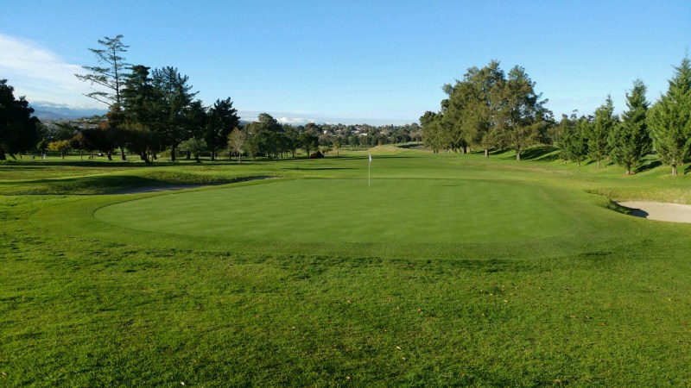

TEES
- 7th and 17th tees coming along nicely and should be playable later this week
- Continue to mow with walk-behinds
- Lower tier on 17th to be over-seeded
- New 6th club tee to be built and ladies tee lowered
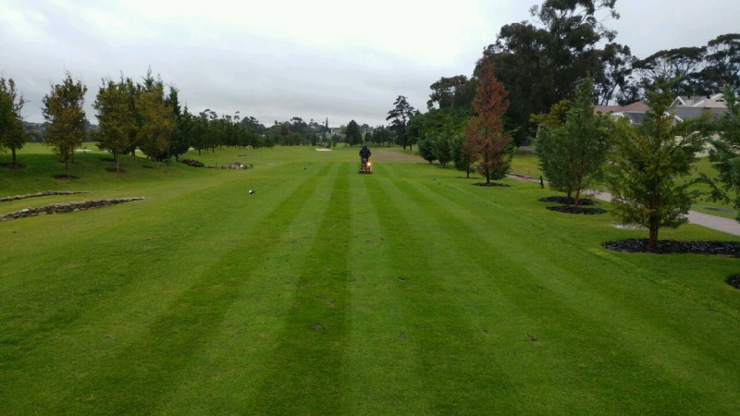

FAIRWAYS
- In good shape at the moment with good coverage
- Reshaping of the 6th fairway to the right and lengthening the 2nd fairway
- 8th fairway wet especially behind the bunker

BUNKERS
- The 2nd bunker is in play but the surrounds GUR
- A trial bunker with a new lining to be started in September
- We continue to fill the bunkers up with sand on an ongoing basis

MACHINERY
- All the machines running well
- Bushes and bearings were replaced on the rough machine so this should neaten up the rough

IRRIGATION
- Busy compiling information on the Variable frequency drives for the pump house
- We will start pumping effluent into the dams as soon as the effluent plant is ready
- An audit of the system has been conducted and we are busy attending to the faults
- Len from Cape Irrigation is due to start the servicing of the Aquagators
- Additional sprinklers to be installed in historically dry areas around playing surfaces

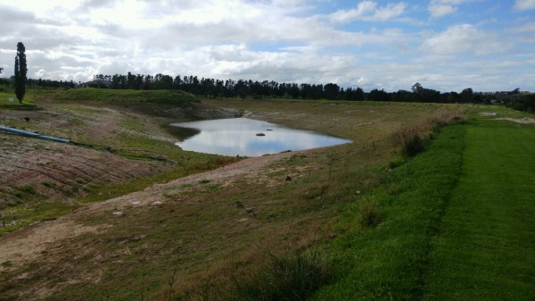

WEATHER
- We have had 26.5mm this month so far. The long term average for August is 104.6mm

OBJECTIVES FOR SEPTEMBER 2017
- Hollow-tining 18th September
- Spring treatment of tees, approaches and fairways
- Spraying of weeds in the rough
- Bunker trial

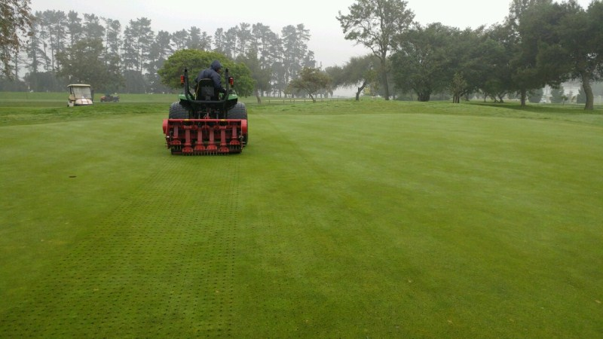

Kind Regards from your Southern Turf Management team

