Local Rules 3
We are still discussing our own Durbanville Local Rules.
Importantly – a Local Rule can never override a Rule of golf. Therefor if a club have unique situations that are not covered by the many Specimen Local Rules for abnormalities in Appendix 1 of the Rule Book, they may refer to the R&A for solving the problem. The R&A will advise as how to treat the special abnormality.
As being said before, always read the Local Rules before playing as a visitor at another club……and also at your own club!
What to do if the list is long? In this modern age, you just take a picture with your cell phone of the notice board and you have your copy.
We are looking at our 3rd Local Rule:

3. EMBEDDED BALL (Rule 25-2)
Anywhere Through the Green, a ball that is embedded in its own pitch mark, may be lifted, cleaned and dropped, without penalty as near as possible to the spot where it lay but not nearer the hole. The ball when dropped must first strike a part of the course Through the Green. Exception: No relief if the ball is embedded in sand in an area that is not closely-mown.

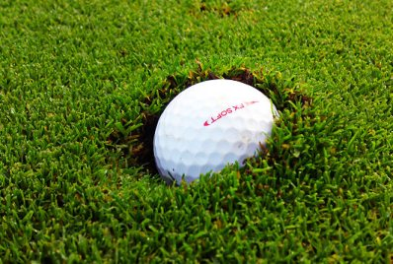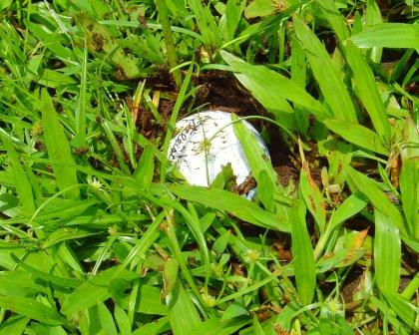

The difference between the Local Rule and the Rule of Golf as in Rule 25 -2, is that it is extended to “Through The Green” in the Local Rule.
What does this now means???
Firstly you have to know the definition of Through the Green:
It is the whole area of the course except:
a. The teeing ground and putting green of the hole being played; and
b. All hazards on the course.
This extension of relief means that even in the rough you may get relief from an embedded ball. But as so many times under The Rules there are EXEPTIONS!!
Exceptions:
1. A player may not take relief under this Local Rule if the ball is embedded in sand in an area that is not closely-mown.
2. A player may not take relief under this Local Rule if interference by anything other than the condition covered by this Local Rule makes the stroke clearly impracticable.

An embedded ball is well described by Decision 25-2/0.5

When Ball Embedded in Ground
A ball is deemed to be embedded in the ground only if:
- the impact of the ball landing has created a pitch-mark in the ground,
- the ball is in its own pitch-mark, and
- part of the ball is below the level of the ground.
Provided that these three requirements are met, a ball does not necessarily have to touch the soil to be considered embedded (e.g., grass, loose impediments or the like may intervene between the ball and the soil).
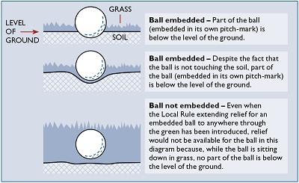
Any doubt as to whether a ball is embedded should be resolved against the player.

What to do if you think that your ball is embedded?

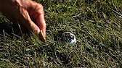
Tell your marker or opponent that you want to check whether it is embedded, mark the ball, lift the ball, do not clean the ball at this stage.
See diagrams above to determine whether it is embedded.
If it is not embedded, you must not clean the ball. Replace the ball where it was.
If it is embedded, you may now clean the ball. Now you may take relief.

Relief:
Without penalty drop the ball AS NEAR AS POSSIBLE to the spot where it lay, not closer to the hole.
If the dropped ball embeds again, you are entitled to relief again as described above.
If it embeds again on the re-drop, the player may now place the ball as near as possible to the spot when re-dropped, not nearer the hole.
If you have taken relief under this rule, played the ball and it climbs a slope and it rolls back into the same pitch mark, there is no relief!
If the ball embeds in GUR, you may take relief for the embedded ball and then play or take relief from the GUR or alternatively, take direct relief from the GUR.
If your ball lies on a steep bank, for example the 14th hole, and you play it straight into the bank, without the ball being airborne, there is no relief under this rule.

