Local Rules 4
4. IMMOVABLE OBSTRUCTIONS (Rule 24-2)
- All artificially surfaced roads/paths, including the cart path running between the 1st and 2nd hole and the dirt cart path on the 12th hole as well as the turning circle, covered by wooden chips, next to the 2nd Teeing Ground.
- Wooden supports for young trees - relief is only available from the support, not the tree.

Per definition: An "obstruction" is anything artificial, including the artificial surfaces and sides of roads and paths and manufactured ice, except: a. Objects defining out of bounds, such as walls, fences, stakes and railings; b. Any part of an immovable artificial object that is out of bounds; and c. Any construction declared by the Committee to be an integral part of the course.
An obstruction is a movable obstruction if it may be moved without unreasonable effort, without unduly delaying play and without causing damage. Otherwise, it is an immovable obstruction.
The dirt cart path on the 12th hole is deemed to be an immovable obstruction, as it can unfairly affect play. See Appendix 1: “Providing relief of the type afforded under Rule 24-2b from roads and paths not having artificial surfaces and sides, if they could unfairly affect play.”

The important issue under the free relief for the above listed is the EXEPTION that comes with this relief:
*EXCEPTIONS: NO RELIEF IS AVAILABLE UNDER THESE ABOVE LOCAL RULES IF:
a) Interference by anything other than the condition covered by these local rules makes the stroke clearly impracticable, or b) interference by the condition covered by these local rules would occur only through use of an unnecessarily abnormal stance, swing or direction of play.

Therefore, if because of some other interference, like for instance a bush or tree, you do not have a swing or stance, you are NOT entitled to relief under this local rule.

The available relief is per Rule 24-2b: Find the nearest point of relief from the obstruction, not nearer the hole and drop a ball within one club length of that spot. It is important to see where this spot might be before lifting the ball, as the relief is NEAREST point and not NICEST point. You have to take full relief – which means if you have taken relief and plays the ball and still hits immovable obstruction, then it is a 2 stroke penalty or loss of hole in match play. If, after dropping the ball, you still have interference, you may re-drop the ball.

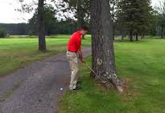
Yes, this is the nearest point of relief! From this point you have a one club length area, not nearer the hole to drop the ball.

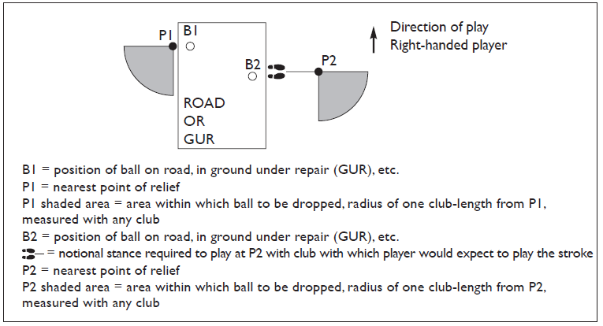
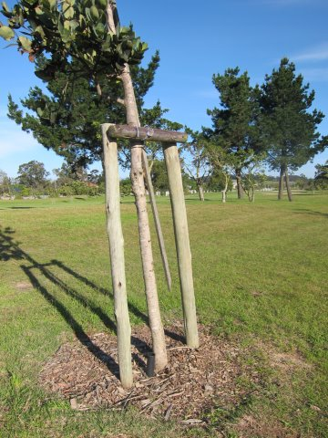
In this example, if the tree is not marked with a small white stake, you only get relief from the poles, as they are immovable obstructions, NOT THE TREE.

Helénè Marais
083 785 8254

