When a Rule is Breached in Stroke Play

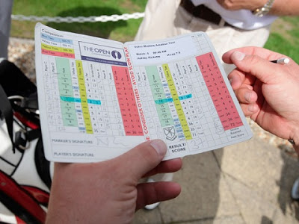
There are four main situations that apply when a Rule of Golf is breached in a stroke play competition;
1. A player breaches a Rule and includes the appropriate penalty on the score card that they sign and return.
2. A player unknowingly breaches a Rule and signs and returns their score card. The breach is brought to the Committee’s attention before the competition has closed.
3. As in 2, but the breach is brought to the Committee’s attention after the competition has closed.
4. A player knowingly breaches a Rule, but does not include the penalty incurred on their score card
So what are the considerations in each of these four scenarios?
1. This does not require any further explanation. It is what should happen every time a Rule is breached.
2. If the breach is brought to the attention of the Committee before the competition has closed, the player incurs the penalty prescribed by the applicable Rule and an additional penalty of two strokes, Exception to Rule 6-6d.
3. If the breach is brought to the attention of the Committee after the competition has closed, a penalty must not be imposed by them unless the breach warranted disqualification under one of these four exceptions that are outlined in Rule 34-1b;
Exceptions: A penalty of disqualification must be imposed after the competition has closed if a competitor:
(i) was in breach of Rule 1-3 (Agreement to Waive Rules); or
(ii) returned a score card on which he had recorded a handicap that, before the competition closed, he knew was higher than that to which he was entitled, and this affected the number of strokes received (Rule 6-2b); or
(iii) returned a score for any hole lower than actually taken (Rule 6-6d) for any reason other than failure to include one or more penalty strokes that, before the competition closed, he did not know he had incurred; or
(iv) knew, before the competition closed, that he had been in breach of any other Rule for which the penalty is disqualification.
4. Call it what you like, but this is cheating. The player must be disqualified and the Committee should consider sanctioning them, e.g. by suspending them from all competitions for a period of time.
Of course, there are sometimes on-course situations where a player may be unsure as to how to proceed without breaching a Rule unnecessarily, e.g. whether they may take relief from equipment damage to the course, or when a fellow competitor tells them that they should be taking relief from a different place from where they think they are permitted to drop a ball. When a competitor is doubtful of their rights or the correct procedure during the play of a hole, they may, without penalty, complete the hole with two balls. If the player chooses to do so they must strictly follow the procedure set out in Rule 3-3;
The competitor should announce to his marker or a fellow-competitor:
• that he intends to play two balls; and
• which ball he wishes to count if the Rules permit the procedure used for that ball.
Before returning his score card, the competitor must report the facts of the situation to the Committee. If he fails to do so, he is disqualified.
If the competitor has taken further action before deciding to play two balls, he has not proceeded under Rule 3-3 and the score with the original ball counts. The competitor incurs no penalty for playing the second ball.
There is a more detailed explanation of Rule 3-3 in this blog of mine.
Two Rules Situations from this week’s tournaments
For Rules enthusiasts, there were two fairly complicated Pro tournament rulings in the past week. I am providing two links to these incidents, rather than giving you my own detailed explanation;
Sergia Garcia getting relief from a really bad lie in a water hazard.
Ben Crane receiving two four-stroke penalties and then disqualification, because of the clubs he was carrying.
Good golfing,

